Dominic Drury

10/07/2024

CS-470

6-2 Project One

**API URL / Endpoint: Backend of the project running.**

<https://rtn5q2g8ed.execute-api.us-east-1.amazonaws.com/api/Questions>

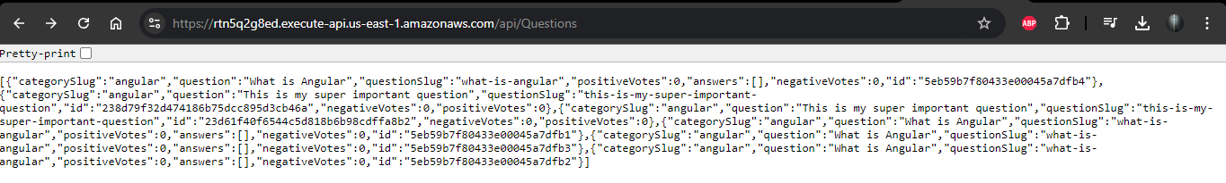<https://rtn5q2g8ed.execute-api.us-east-1.amazonaws.com/api/Answers>

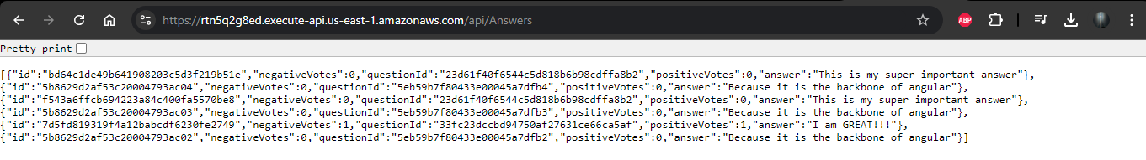**S3 URL / Endpoint: Frontend of the project hosted on S3.**

<http://drury.lafs.web.s3-website-us-east-1.amazonaws.com/questions/about/angular>

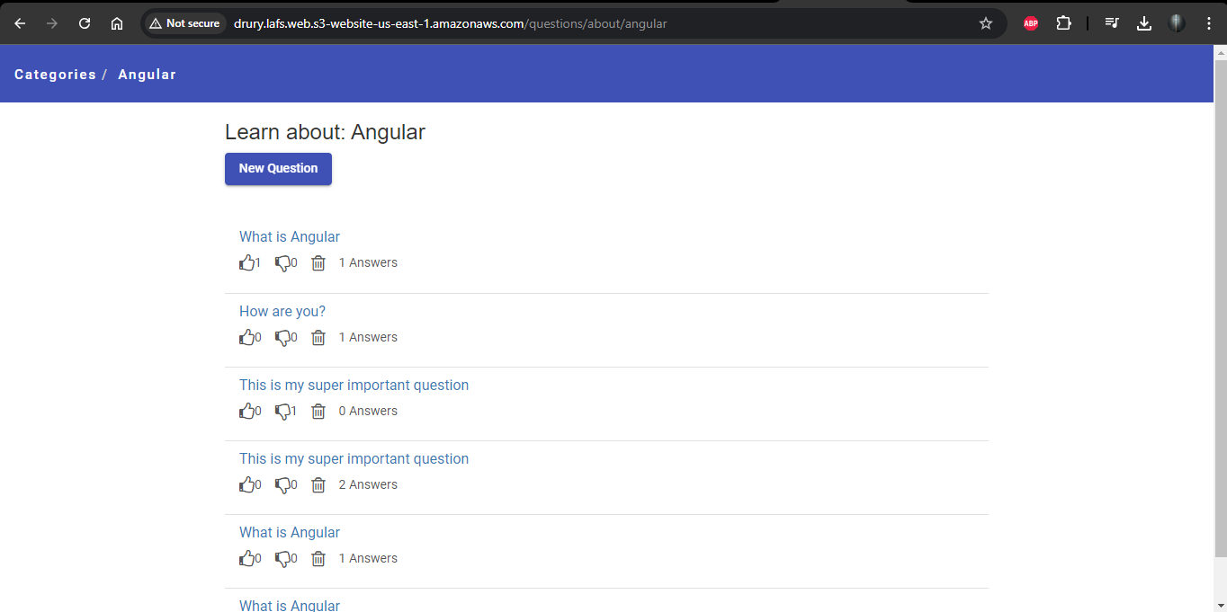

**Part One: The Questions API**

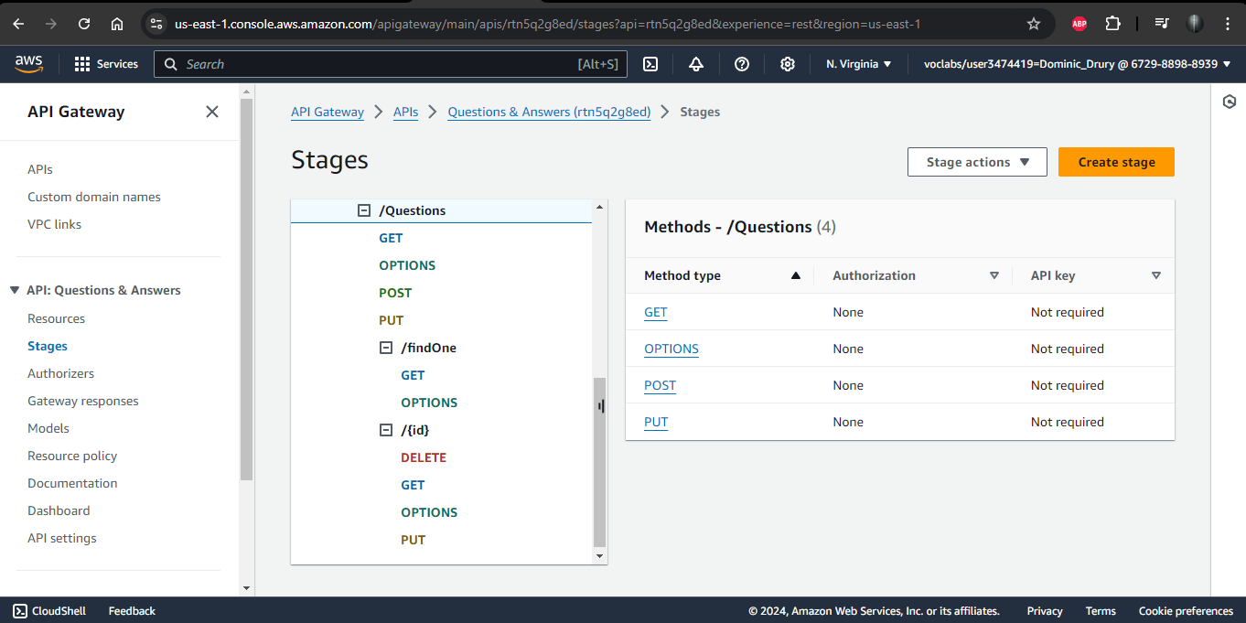

**Part Two: The Answers API**

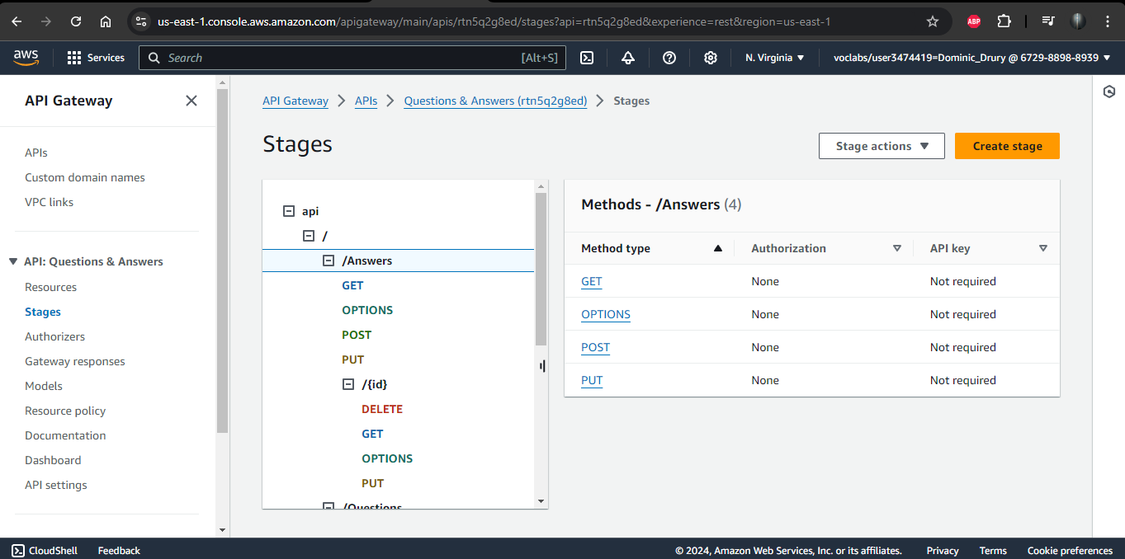

**Supporting CORS**

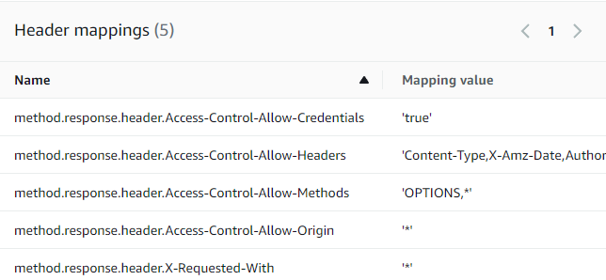

**Deployment**

